Survey Report
As of 21:53 on 7th 10 2025

Before writing this report, three members of the Residents’ Association Committee reviewed all entries to ensure the feedback from the survey was accurately represented.
The results are below.
Q1 was “Do you believe that the Racecourse at Newbury needs a community centre?”
Valid Responses after being checked for no repeats was 98 (See graph below)
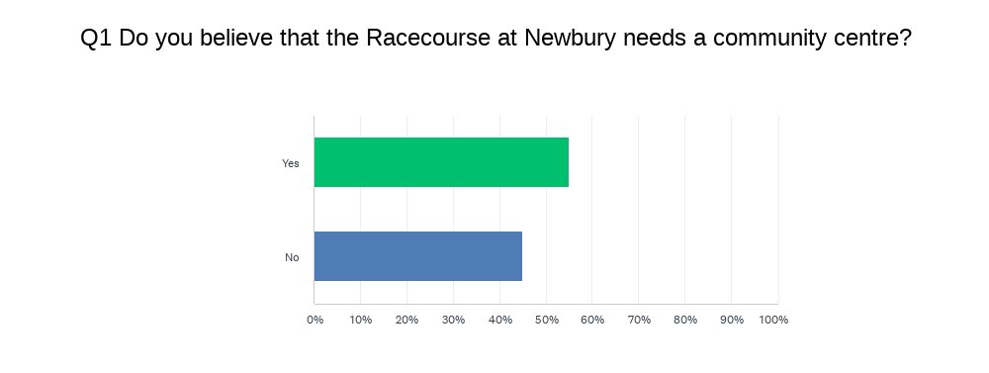
Q2 was “Do you think the Marketing suite is a suitable location for the community centre. The marketing suite is located just to the left as you come into the racecourse estate.”
Split of Valid votes 54 Yes 44 No
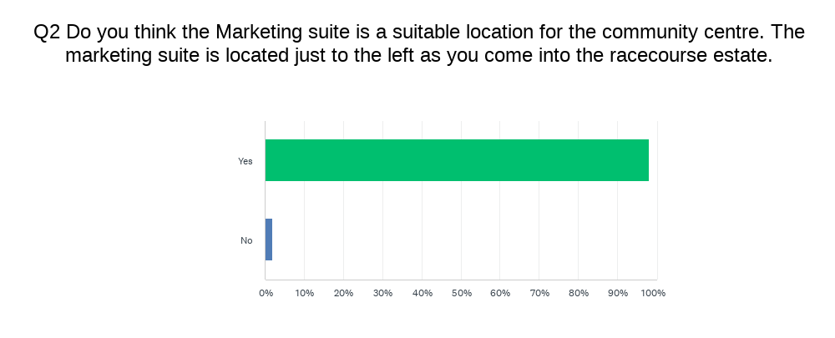
98% of those answering the question “is the location suitable” said Yes
Q3 was “If you answered "No" above then please share where you think it should be placed.”
Although 4 people entered something no alternative location was proposed
Q4 was “What uses for the community would you like to see? (Select all that apply)”
The breakdown of what uses might be suitable yielded some useful information
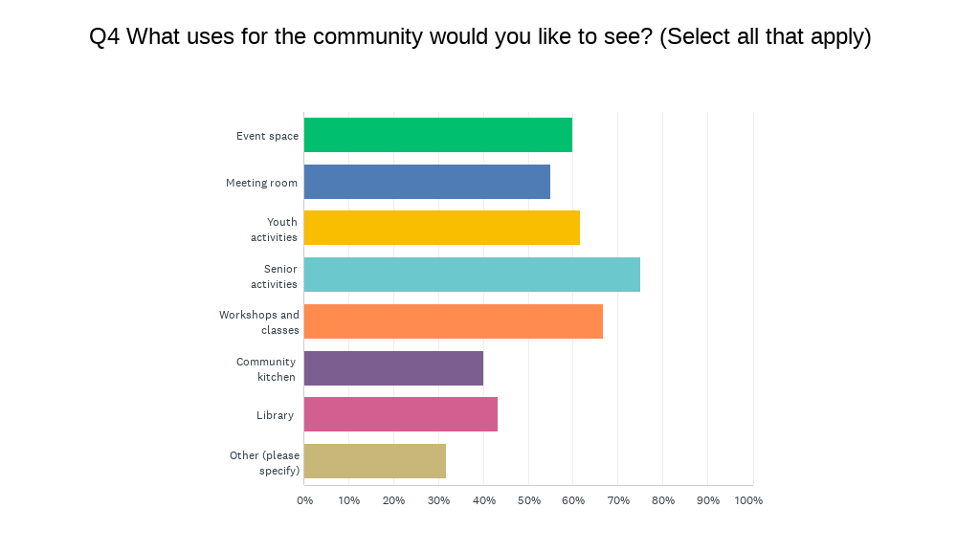
Other uses suggested included.
- Internet support,
- U3A,
- Community Café,
- Card Club,
- It Help centre,
- Charity Events,
- Shop,
- Rehabilitation centre,
- Police and social drop in ,
- Ev Charging area & Social club.
Community café was the largest request from the Other response.

Q5 was “If you answered "No" to Q1 could you say why please. This is in case the reason can be addressed. This would be important if the majority were in favour of having one.”
A total of 44 people said "No" to a community centre and provided one or more reasons. These responses were categorised into the following groups.
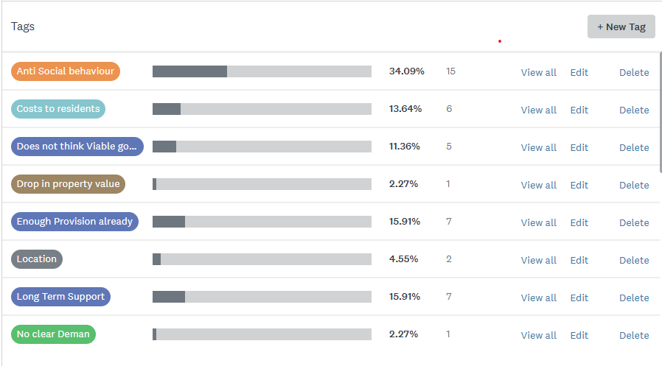
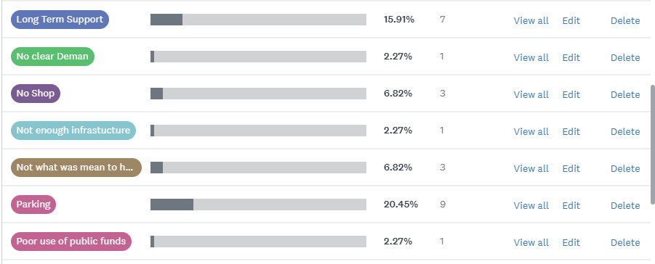
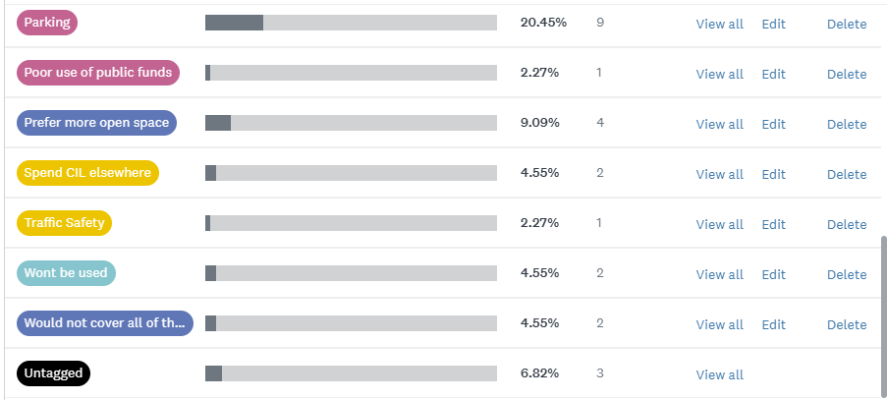

Survey Summary: Community Centre Proposal
The recent survey should not be considered statistically significant. It was distributed solely via available Facebook groups, reaching approximately 2,000 residents. For statistical validity, a response rate of 200–320 votes would have been required. Any future GPC survey should aim to secure over 300 responses to ensure confidence that the results genuinely reflect the views of the target community.
Key Findings
The most prominent concern raised was the potential for increased anti-social behaviour resulting from the establishment of a community centre. Other notable concerns included:
- Ongoing costs to residents
- Parking availability
- Long-term sustainability and support
One issue—“No Shop”—is expected to be resolved with the delivery of the Local Centre directly opposite the suite. Units are already being advertised for retail use.
Concerns about the centre’s viability emerged in various forms. It is clear that any decision to proceed should be based on robust evidence demonstrating that the facility could be self-sustaining.
Response Data
- Total responses (including spoiled votes): 127
- Spoiled votes: 29 submissions lacked both name and postcode, which were mandatory fields used to ensure one vote per person.
- Spoiled vote breakdown: 10 Yes, 19 No
Even when spoiled votes are included, the percentage in favour decreases but still represents the larger share.

